**Problem Statement**: **Employee Hierarchy Generation : -**

You are tasked with creating a stored procedure to generate an employee hierarchy based on

the data stored in the EMPLOYEE_MASTER table. Additionally, you need to create a table named Employee_Hierarchy to store the final hierarchy output.

The EMPLOYEE_MASTER table contains information about employees, including their EmployeelD, the ID of the employee they report to (ReportingTo), and their email address (EmailID). However, the email addresses need to be split into first and last names, excluding the

domain name.

Here are the specific requirements:

**Stored Procedure (SP_hierarchy)**:

* Create a stored procedure named SP_hierarchy to generate the employee hierarchy.
* The procedure should truncate the Employee_Hierarchy table before processing to ensure a fresh insertion of the hierarchy data.
* The hierarchy should be generated recursively, starting from employees who do not report to anyone (i.e., have NULL in the ReportingTo column).
* For each employee in the hierarchy, calculate their level in the hierarchy.
* Split the email addresses into first and last names (excluding the domain name) and store them in separate columns.
* Insert the final hierarchy data into the Employee_Hierarchy table.

**Employee_Hierarchy Table:** Create a table named Employee_Hierarchy with the following

**schema:**

* EMPLOYEEID: VARCHAR(20) REPORTINGTO: NVARCHAR(MAX) EMAILID: NVARCHAR(MAX)
* LEVEL: INT
* FIRSTNAME: NVARCHAR(MAX)
* LASTNAME: NVARCHAR(MAX)

·

**Functions:** Create two functions to extract first and last names from email addresses:

* Function to extract the first name: [FIRST_NAME]
* Function to extract the last name: [Last_Name]

**Employee_Master(INPUT)** Table**: -**

|  |  |  |
| --- | --- | --- |
| **EmployeeID** | **ReportingTo** | **EmailID** |
| H1 | NULL | john.doe@example.com |
| H2 | NULL | jane.smith@example.com |
| H3 | John Smith H1 | alice.jones@example.com |
| H4 | Jane Doe H1 | bob.white@example.com |
| H5 | John Smith H3 | Charlie.brown@example.com |
| H6 | Jane Doe H3 | david.green@example.com |
| H7 | John Smith H4 | Emily.grey@example.com |
| H8 | Jane Doe H4 | Frank.wilson@example.com |
| H9 | John Smith H5 | George.harris@example.com |
| H10 | Jane Doe H5 | Hannah.taylor@example.com |
| H11 | John Smith H6 | irene.martin@example.com |
| H12 | Jane Doe H6 | jack.roberts@example.com |
| H13 | John Smith H7 | kate.evans@example.com |
| H14 | Jane Doe H7 | laura.hall@example.com |
| H15 | John Smith H8 | mike.anderson@example.com |
| H16 | Jane Doe H8 | natalie.clark@example.com |
| H17 | John Smith H9 | oliver.davis@example.com |
| H18 | Jane Doe H9 | peter.edwards@example.com |
| H19 | John Smith H10 | quinn.fisher@example.com |
| H20 | Jane Doe H10 | rachel.garcia@example.com |
| H21 | John Smith H11 | sarah.hernandez@example.com |
| H22 | Jane Doe H11 | thomas.lee@example.com |
| H23 | John Smith H12 | ursula.lopez@example.com |
| H24 | Jane Doe H12 | victor.martinez@example.com |
| H25 | John Smith H13 | william.nguyen@example.com |
| H26 | Jane Doe H13 | xavier.ortiz@example.com |
| H27 | John Smith H14 | Yvonne.perez@example.com |
| H28 | Jane Doe H14 | Zoe.quinn@example.com |
| H29 | John Smith H15 | Adam.robinson@example.com |
| H30 | Jane Doe H15 | barbara.smith@example.com |

**Employee_Hierarchy(OUTPUT) TABLE**: -

|  |  |  |  |  |  |
| --- | --- | --- | --- | --- | --- |
| **EmployeeID** | **ReportingTo** | **EmailID** | **Level** | **FirstName** | **LastName** |
| **H1** | **NULL** | john.doe@example.com | **1** | **john** | **doe** |
| **H2** | NULL | **jane.smith@example.com** | **1** | **jane** | **smith** |
| H3 | **John Smith H1** | **alice.jones@example.com** | **2** | **alice** | jones |
| **H4** | **Jane** Doe **H1** | **bob.white@example.com** | **2** | bob | **white** |
| **H7** | **John Smith** H4 | **emily.gray@example.com** | **3** | **emily** | **gray** |
| H8 | Jane Doe H4 | frank.wilson@example.com | **3** | **frank** | **wilson** |
| H15 | **John Smith** H8 | **mike.anderson@example.com** | **4** | **mike** | **anderson** |
| **H16** | Jane Doe H8 | natalie.clark@example.com | **4** | **natalie** | **clark** |
| H29 | **John Smith** H15 | **adam.robinson@example.com** | **5** | **adam** | **robinson** |
| **H30** | Jane **Doe H15** | **barbara.smith@example.com** | **5** | **barbara** | **smith** |
| **H13** | **John Smith H7** | **kate.evans@example.com** | **4** | **kate** | **evans** |
| **H14** | Jane Doe H7 | **laura.hall@example.com** | **4** | laura | **hall** |
| **H27** | **John** Smith **H14** | **yvonne.perez@example.com** | **5** | **yvonne** | **perez** |
| **H28** | Jane Doe **H14** | **zoe.quinn@example.com** | **5** | **zoe** | **quinn** |
| **H25** | **John** Smith **H13** | **william.nguyen@example.com** | **5** | **william** | **nguyen** |
| H26 | **Jane Doe H13** | **xavier.ortiz@example.com** | **5** | **xavier** | **ortiz** |
| **H5** | **John Smith H3** | **charlie.brown@example.com** | **3** | **charlie** | **brown** |
| H6 | **Jane** Doe **H3** | **david.green@example.com** | **3** | **david** | **green** |
| H11 | **John** Smith H6 | irene.martin@example.com | **4** | **irene** | **martin** |
| **H12** | Jane Doe H6 | **jack.roberts@example.com** | **4** | **jack** | **roberts** |
| **H23** | John Smith **H12** | **ursula.lopez@example.com** | **LO** | **5** | ursula |
| **lopez** | H24 | **Jane Doe H12** | **victor.martinez@example.com** | **5** | victor |
| **martinez** | **H21** | **John** Smith **H11** | **sarah.hernandez@example.com** | **5** | **sarah** |
| **hernandez** | **H22** | **Jane** Doe **H11** | **thomas.lee@example.com** | **5** | **thomas** |
| **lee** | H9 | **John Smith H5** | **george.harris@example.com** | **4** | **george** |
| **harris** | H10 | Jane Doe **H5** | hannah.taylor@example.com | 4 | **hannah** |
| taylor | **H19** | **John Smith H10** | quinn.fisher@example.com | **5** | **quinn** |
| **fisher** | H20 | Jane Doe H10 | rachel.garcia@example.com | **5** | **rachel** |
| garcia | H17 | **John** Smith H9 | **oliver.davis@example.com** | **5** | oliver |
| davis | **H18** | **Jane** Doe H9 | peter.edwards@example.com | **LO** | **5** |
| **peter** | **edwards** |  |  |  |  |

____________________________________________________________

Name : Avilash Bhowmick  
Internship ID : CT_CSI_SQ_1835  
Project : Employee Hierarchy Generation

Solutions :  
  
  
Task Summary as per the project given :

1. **Create the Employee_Hierarchy Table:** You are required to create a new table named Employee_Hierarchy with the specified schema, which includes columns for EmployeeID, ReportingTo, EmailID, Level, FirstName, and LastName.
2. **Create Functions to Extract Names:** You need to create two functions: FIRST_NAME to extract the first name from an email address, and LAST_NAME to extract the last name. These functions will be used to split the email addresses from the EMPLOYEE_MASTER table into first and last names, excluding the domain name.
3. **Create the Stored Procedure SP_hierarchy:** Develop a stored procedure named SP_hierarchy that will generate the employee hierarchy. This procedure should:

* Truncate the Employee_Hierarchy table to ensure a fresh start.
* Recursively generate the hierarchy, starting with employees who have no superior (NULL in the ReportingTo column).
* Calculate the level of each employee in the hierarchy.
* Use the FIRST_NAME and LAST_NAME functions to split the email addresses into first and last names.
* Insert the resulting hierarchy data into the Employee_Hierarchy table.

1. **Populate the Employee_Hierarchy Table:** Execute the SP_hierarchy stored procedure to populate the Employee_Hierarchy table with the generated hierarchy data.
2. **Verify the Output:** Ensure that the Employee_Hierarchy table is correctly populated with the employee hierarchy, including the levels and the split first and last names derived from the email addresses.

Queries based upon task given :

**Step 1: Create the Employee_Hierarchy Table**

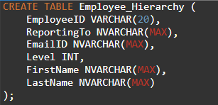

**Step 2: Create Functions to Extract First and Last Names**

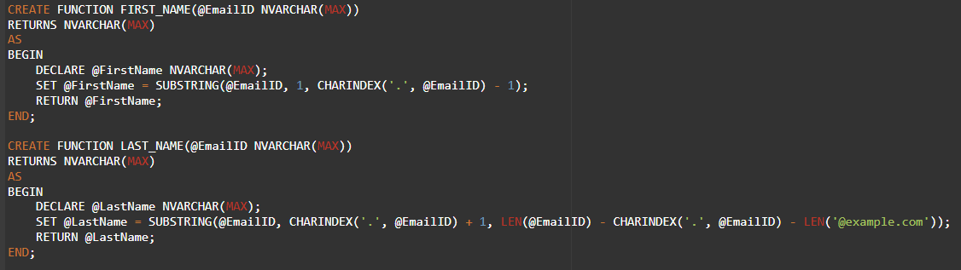

**Step 3: Create the Stored Procedure SP_hierarchy**

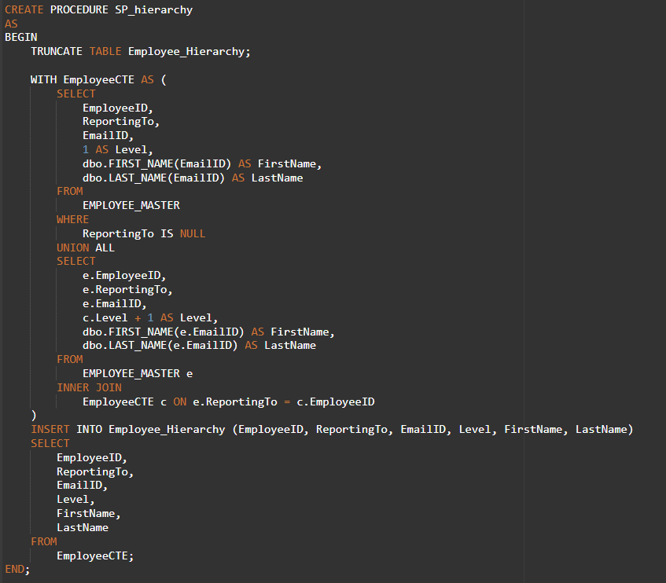

**Step 4: Execute the Stored Procedure to Populate the Employee_Hierarchy Table**



**Step 5: Verify the Output in the Employee_Hierarchy Table**

  
  
Output :  
